
BizTalk Accelerator for Retail
Solution Offering Proposal
July 23, 2001
The purpose of this document is to propose the creation of a BizTalk Accelerator for Retail based on the work done to date to deliver the Procter and Gamble Fireball Project.

Scenario statement

Agile businesses thrive by quickly realigning to new market conditions. For retailers, the timely consolidation, transformation, and distribution of their sales data within and outside of their enterprise drives this capability. Internally, transaction data supports core operational systems like replenishment, merchandising, and financials, as well as business intelligence solutions like loyalty, shrink and loss prevention. Externally, manufacturers and suppliers rely on sales data to understand consumption trends, market share, and the impact of promotional activities. Thus transaction data is the fuel for channel collaboration.
That said, while retailers certainly recognize the value of integrating these desperate systems, most lack the technical infrastructure and resource capacity to easily achieve these results. The BizTalk Accelerator for Retail delivers a cost effective solution to this dilemma.
With the BizTalk Accelerator for Retail, the retailer’s real-time, or near real-time, collection of their transaction data can be easily transformed and routed to the appropriate decision support and ERP systems. Additionally it can be filtered, transformed, and routed to the retailer’s supply chain partners or web service providers.
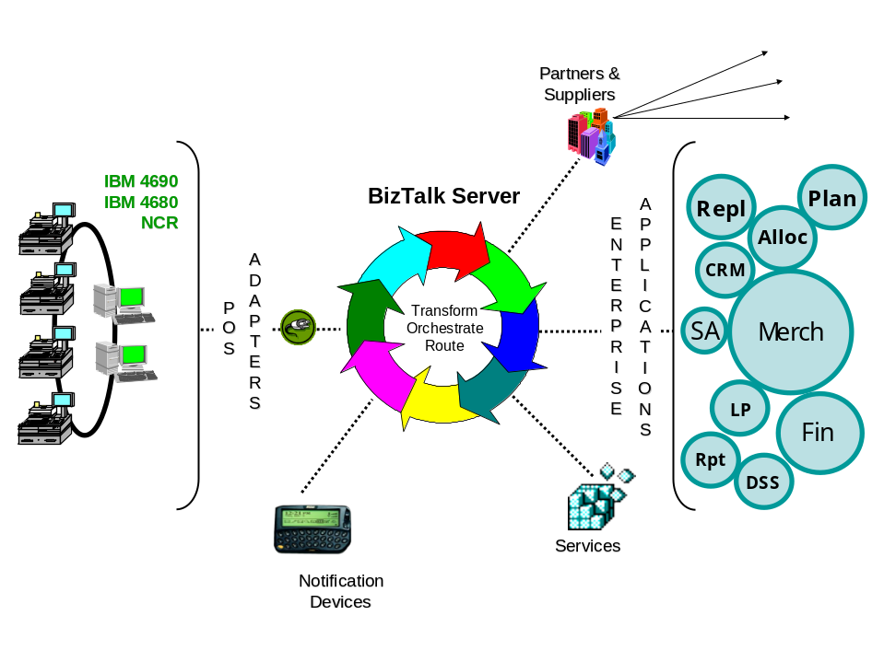
The value of the Retail Accelerator is currently being demonstrated via pilot engagements with several retailers. These engagements are delivering a Consumer Demand Signal Service (CDS) which monitors merchandise turn rates (via the transaction data feed) and alerts store personnel of potential out-of-stock conditions. CDS will become the catalyst for a broader supply chain orchestration initiative with consumer products giant Procter and Gamble (Fireball Project). Here again, the Accelerator’s value proposition will be further demonstrated by orchestrating the supply chain’s reaction to the near real-time consumer demand (transaction) data stream.

Solution Definition

This offering is an infrastructure, built on the .Net framework, which can support numerous web services as well as deliver EAI and BI capability. As such, its development will be as much about partner orchestration as it is about IP creation.
The BizTalk Accelerator for Retail includes a set of tools and technical resources that enhance the functionality of BizTalk Server 2000 to significantly reduce the amount of time and resources required to acquire, transform, and route POS transaction data.
The key components are:
- POS Adapter Portfolio for BizTalk Server 2000. These adapters address the most common store automation platforms including IBM 4690, IBM 4680, and NCR and enable the translation of the data stream into XML.
- Tools and Documentation. Guidelines and tools for parsing and transforming the XML output as required.
- Services Catalog. A .Net based services catalog of the solutions supported by the infrastructure.

Opportunity / Target Market

This offering has broad applicability across the retail space. It is sold as a solution, and once in place, it provides a foundation for incremental sales and services opportunities for both Microsoft and our partners. From the retailer’s perspective, the solution is flexible and expandable making ROI justification and internal selling easy.
For now, the solution driving adoption of this infrastructure is the Consumer Demand Signal Service from the Fireball project. P&G is championing this solution and its adoption to every major retailer in the world – starting with the key industry influencers. The solution is live at Meijer and Food Lion and will go live at Giant (Ahold) in August. Additional near term opportunities include: Target and Wal-mart in the United States; Sainsbury and/or Tesco in Europe; and Bompresco (Ahold) in Latin America. Outside of the P&G initiative, opportunities exist at Kroger, Marathon Oil, and Transora.

Product Inventory (Bill of Materials)
As this is not a Sable solution, the specific product SKUs have yet to be determined, but below is a general look at the possible components.

Target Market | Solution SKU | Core/Optional | Product SKUs | Functional Value
 | BizTalk Accelerator for Retail Standard | Core | Accelerator | POS Adapter Portfolio  Tools and Documentation  Services Catalog
 | BizTalk Accelerator for Retail Standard | Core | BizTalk Server 2000 | Platform for Accelerator implementation
 | BizTalk Accelerator for Retail Standard | Core | SQL Server 2000 | Database server for BizTalk Server
 | BizTalk Accelerator for Retail Standard | Core | Windows 2000 Server | Core underlying platform
 | BizTalk Accelerator for Retail Standard | Optional | Host Integration Server | Integration with existing/legacy systems
Partner Products and Custom Components
Partners play a key role in this service offering, not only delivering the POS Adapter Portfolio, but also the catalog of services. Systech Retail Systems has delivered the IBM 4690 POS Adapter for the Giant (Ahold) pilot. We are leveraging an existing code base for them and the solution will likely require modification.
To support P&G, NCR will be a requirement in the spring 2002 time frame.
Other potential partners include:

Source | Core / Optional | Product SKUs | Functional Value
Matra Systems, Inc. | Optional | Freedom – ISP | Trickle solution for 46x0 and NCR POS systems. Applicable if the retailer is not currently collecting POS data at the enterprise level.
QVS | Optional |  | 46x0 controller replacement product. Applicable where no trickle solution is in place and no Windows box in the store.
Systech Retail Systems (www.srspos.com) | Optional | Retail Connector Switch | 4690 POS Adapter
Xceed Software  http://www.xceedsoft.com/xceedsoft1.1/products/biztalk/index.shtm | Core | FTP Library for BizTalk Server | FTP file transfer between systems
Data Return | Optional |  | Hosting
Compaq | Optional |  | Hosting, Hardware

Solution Stack
A view of the solution stack for the Accelerator:
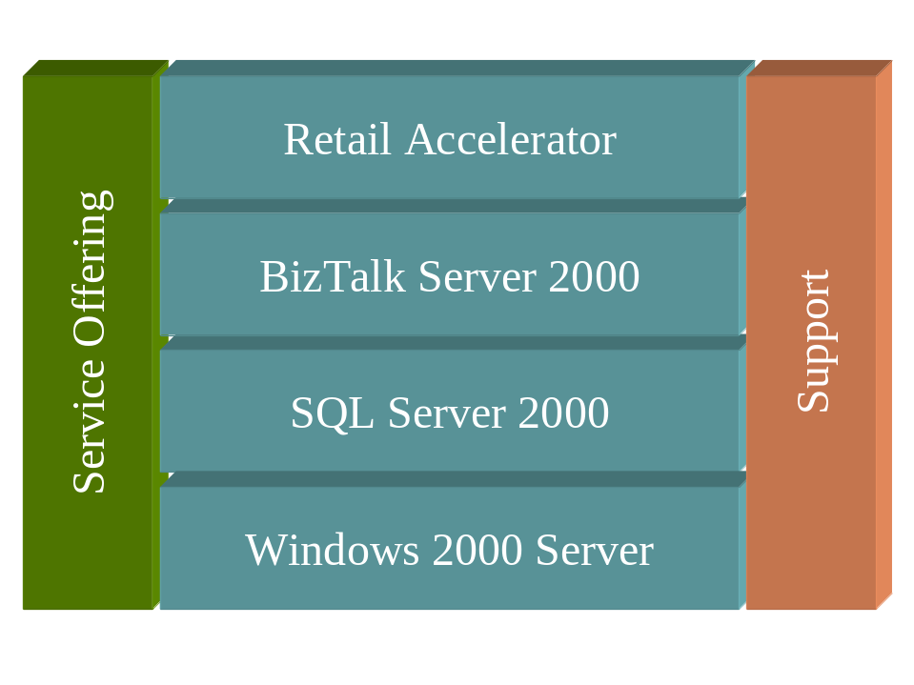
Infrastructure platform requirements
The solution currently requires the regular consolidation of the retailer’s transaction data at the enterprise level. Retailer’s not currently trickle polling their data will need to implement a trickle solution. This increases the cost of the solution and has bandwidth requirements that some retailers may not be prepared to address. Alternatives exist for in-store deployment models, but BizTalk licensing relief will be necessary to deliver ROI for the retailer.
Depending on the depth and breadth of the POS Adapter Portfolio, there may be limitations on the POS systems supported by the offering.
Other platform and infrastructure requirements will be dictated by the particular solution/service/integration scenario being implemented.

